Task 1 – Graphs

______________ Type of graphs show proportions

______________ Type of graphs show trends

______________ Type of graphs compare data
Fill in the name of the graph: Line, Bar or pie chart

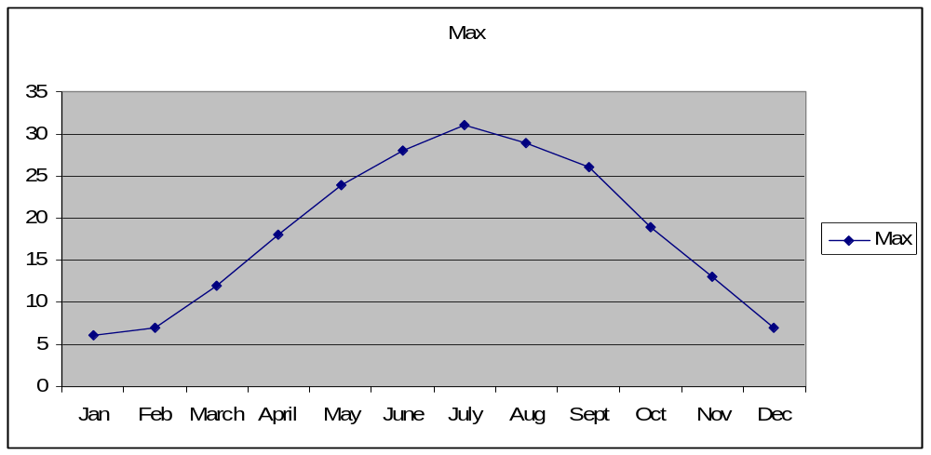
Why is the graph chosen above appropriate for the data?

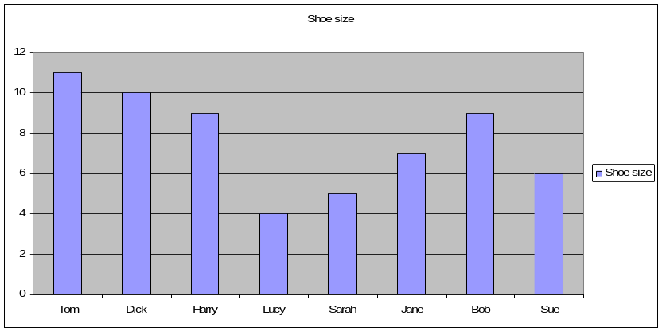
Why is the graph chosen above appropriate for the data?

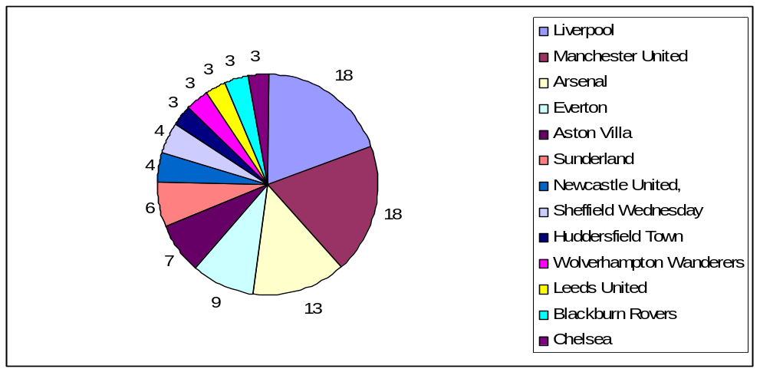

Why is the graph chosen above appropriate for the data?

